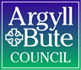

Standards and Quality Report 2020-2021

Name of school
Furnace PS

Context of the school
Including some or all of the following:
- basic school details (roll, class composition etc.)
- school vision, value and aims;
- local contextual issues;
- factors affecting progress (e.g. staffing changes/issues).

Furnace PS is a small rural school in the heart of the village with a roll of 12 children. There are 6 children in P2-4 and 6 in P3-7. There are no P1 or P5 children.
Our Vision is to create a caring and relaxed environment in which each child is encouraged to develop to his/her full potential in all areas of schoolwork and life to develop as independent, creative and confident individuals who respect the views, opinions and beliefs of others.

Our Values To be: Forward thinking, Unique, Respectful, Nurturing, Accepting, Creative and Energetic.

Our Aims: We aim to enable all children to:
- be polite and caring, respecting themselves, others and the environment.
- have a passion and need for learning and experience success.
- enjoy their primary school years and develop high self –esteem, regardless of academic ability.
- have access to a broad, varied, well planned and forward thinking curriculum, which takes account of pupil voice.
- develop an appreciation of the beauty and diversity of their world and acknowledge their part in maintaining and protecting it.

The staffing allocation for Furnace PS is 1.6. Miss Jeromson teaches P2-4 Mon, Wed and Frid.
Mrs Goodwin teaches P4-7 full time and the whole school Tuesdays and Thursdays with one day’s management time once a fortnight.
Due to the global pandemic some children found home schooling difficult and did not engage with the activities. Since returning to school they have found it difficult to readjust to the school routine and this has been reflected in the quality of work produced and the behaviour of a high number of children..

Review of SIP | Priority 1 Embedding outdoor learning across the curriculum especially in Literacy and Numeracy.
Progress and Impact
- Teacher training in Outdoor learning through ‘The Muddy Puddle Teacher Accredited Gold Course’ did not happen due to pandemic.
- Progressive framework in IDL showing skills development was not actioned.
- Outdoor activities to support the understanding of maths concepts were planned as part of home schooling and class work.
- Orienteering and archery skills were not possible.

Next Steps: Focus on outdoor learning in literacy to enhance Listening and Talking Skills.
To prioritise outdoor learning in literacy to enhance Listening and Talking through detailed planning. This is in response to a marked digression in children’s ability to listen to and process instructions after Lockdown.

Develop leadership skills in P5 and P7 through outdoor games.

Review of SIP | Priority 2 To raise attainment in Literacy
Progress and Impact:
- Almost all upper primary children ( P3-7) showed some improvement or levels remained stable in Reading, Writing and Spelling.
- 80% of P2-4 children showed an improvement in their Spelling ages although 66% are working well below their chronological age.
- 100% of P3-7 children showed an improvement in their Spelling attainment levels but the majority are working well below their chronological ages.
- Out of three P7 children 2 have secured second level Reading.
- 50% of whole school Reading attainment is average or above.
Writing: Planned writing improvement development did not go ahead due to home schooling restrictions. Confidence in writing has dipped.
Reading: Use of ‘Epic!’ online library has evoked an interest in reading for pleasure in most children.
Spelling: Intense daily focus on the phonetic qualities of words and implementation of new Spelling resource beginning to show satisfactory results. 90% increase in Spelling ages although 75% still working below chronological age.

Next Steps: To develop writing and raise attainment levels throughout the school.
•Individualised curriculum planning for some children to support learning in Literacy.

•Continued teaching of writing using the Big Writing resource to support the development of whole school writing skills.

•Continued implementation of new whole school Spelling resource-Sounds in Phonics to raise spelling attainment.

- Use of ICT to empower children to become confident in talking about their learning and can instruct, inform others through solo talks, Power Points etc.

Review of SIP | Priority 3 To develop whole school delivery of STEM subjects
Progress and Impact:
Lessons were delivered with an IDL focus.

Due to Covid links with Inveraray PS were not established.
3 year rolling programme was not completed due to time pressures related to the pandemic.

Next Steps:
Priority has been changed due to the immediate need for a focus on raising attainment in literacy and numeracy.

Review of SIP | GME Priority
Progress and Impact:
Next Steps:

Review of SIP | Developing in Faith Priority
Progress and Impact:
Next Steps:

1.1 Attainment Data
Attainment of Literacy Curriculum for Excellence levels 2016/17, 2017/18, 2018/19, and 2019/20 (teacher judgement – confirmed levels – 4 year trend).
*Example below- school-specific data will be provided in the summer term
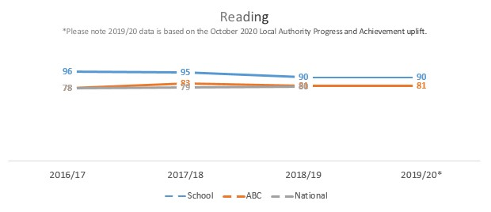
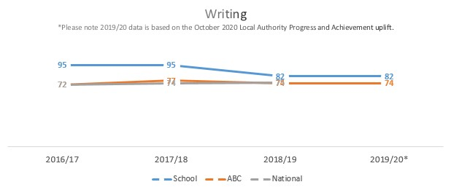
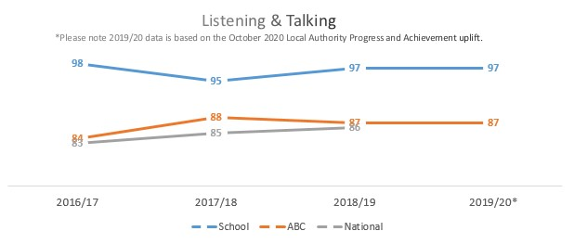

1.2 Attainment Data
Attainment of Numeracy Curriculum for Excellence levels 2016/17, 2017/18, 2018/19, and 2019/20 (teacher judgement – confirmed levels – 4 year trend).
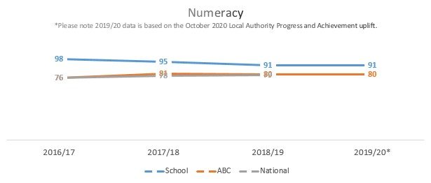

Please Note:
The above data (1.1 and 1.2) reports achievement of a level – P1/P4/P7 combined.
* Due to the Covid 19 pandemic, there was no collection of ACEL data by Scottish Government in 2020. Please note that the 2019/20 data is based on the October 2020 Local Authority Progress and Achievement uplift and cannot therefore be used to demonstrate school or authority improvement compared with previous years. Care is required when making any comparisons drawing on the 2020 data.

Overall quality of our learners’ wider achievements Highlights of session 2020-21
Children have engaged in more family based activities with a health and well being focus – nature walks, cooking and baking.
A love of reading has been developed by some children using the ‘Epic!’ online library.

Comment on strategies that have been successful in engaging with children and young people, staff, parents and the wider community and the impact of these.
During Lockdown and school closure we adapted our teaching using Seesaw. This proved to be easier for parents and children to navigate than Google Classroom and will be utilised next session to share work with home, develop evidence of learning and as a tool to set home work.

Comment on progress made with the following aspects of empowerment:
- curriculum;
- improvement activities;
- parental and community engagement; and pupil participation.

https://education.gov.scot/improvement/learning-resources/an-empowered-system/?dm_i=LQE,6RTY0,WAUPY4,R37A1,1
- One pupil recorded cooking lessons to share with the wider school community via social media.
- Parents working alongside school to deliver home schooling activities.
- 66% of P3-7 children started using the online library at home to develop their reading skills and enjoyment of books.
- Some children discovered a presenting skill through recording and commentating during tasks then submitting to school.

Comment on progress made with Pupil Equity Funding, taking account of the five key areas below:
- attendance;
- attainment;
- exclusion;
- engagement;
- participation.

Implementation of the new Project X readers in the P3-7 class contributed to a 100% increase in reading ages.
Participation in Book bug sessions resulted in fostering a love of books in the P2-4 class.
Once restarted, there was a 40% uptake of the breakfast club facility.

Many initiatives could not go ahead due to Covid restrictions: Cooking Club, Archery, Ballet, Story Sacks for older children.

Quality Indicator | How are we doing? | How do we know? (Evidence) | School Self-Evaluation (1-6)
1.1  Self-Evaluation for Self-improvement | - New whole school differentiated spelling resource implemented to support the learning of phonics and word construction and improve spelling ages.  - Project X Reading scheme added to P2-4 to modernise material and content and encourage engagement of readers to raise attainment in reading. | - 80% of P3-7 spelling ages increased although not to chronological age yet.  - 30% of P2-4 spelling ages increased.  - 100% of P3-7 attained a higher reading age over 8 months although 50% still under chronological age. | 3
1.3  Leadership of Change | - Increased emphasis on H&WB to support anxiety after lockdown. ( Staggered start times/ longer ‘down times’, mindful walks, meditation)  - Staff training on use of Seesaw to facilitate home schooling.  - Implementation of safety procedures within school due to Covid.  - Installation of new mobile kitchen for pupil use.  - Implementation of a reduced curriculum to allow children to readapt to the school routine.  - Use of ICT to communicate with parents through Seesaw and FB messenger group. | - 50% of children struggled to abide by school rules and demonstrate appropriate behaviour.  - 50% engagement during homeschooling.  - Children adapted to new safety procedures well.  - Parents voiced a preference for Seesaw and FB messenger rather than Google Classroom- ease of use. | 3
2.3  Learning, teaching and assessment | - An improved delivery of whole school Spelling strategies using new ‘Sounds in Focus’ resource.  - Use of ‘Seesaw’ to enhance home learning and record achievements in school to be viewed at home by parents.  - Staff refresher work done on new GL Assessment focussing on data to inform future learning. | - 80% of P3-7 spelling ages increased although not to chronological age yet.  - 30% of P2-4 spelling ages increased. | 3
3.1  Ensuring wellbeing, equality and inclusion | - Whole school Spelling resource used from P2-7 creating a uniform approach by all staff.  - Joint collaboration between older and younger pupils during IDL activities.  - Equal access to wellbeing activities where children experience activities they may not normally be able to due to financial restrictions. | See above for Spelling results.  Improved teamwork developing and talking skills.( Creating a board game task) | 3
3.2  Raising attainment and achievement | - Continued implementation of new Spelling Resource.  - Focus on Reading for pleasure through online library ‘Epic!’ and Project X readers.  - Focus on H&WB enabled through PEF spending although limited due to Covid restrictions. | See above.  100% increase in reading ages in P3-7 with 50% achieving above their chronological ages.  Children calm and focussed during horse riding and able to talk about it afterwards to others. | 3

